LED Laser Effect Light
User Manual

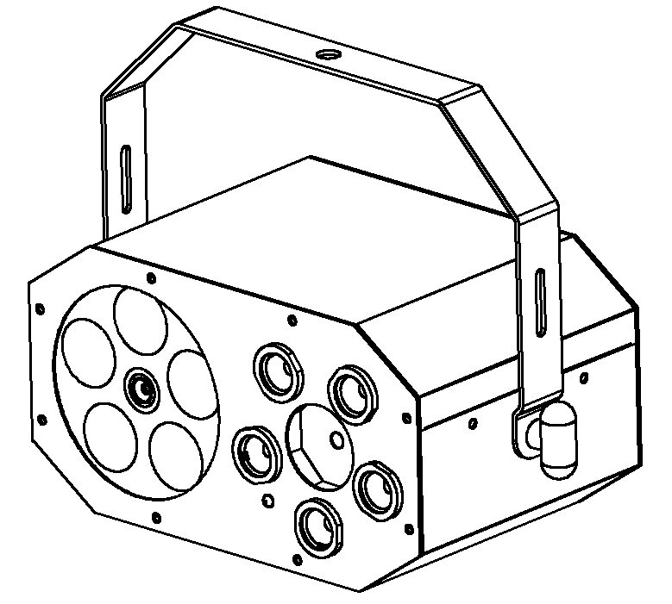

Please keep read this manual carefully for further use!

Content

Introduction---------------------------------------------------------------------------------- P2

Silkscreen symbol-------------------------------------------------------------------------- P3

Safety/specification-----------------------------------------------------------------------P4

Operation menu--------------------------------------------------------------------------------P5

Remote control map----------------------------------------------------------------P6

Rigging/Product size---------------------------------------------------------------------P7

Product size/ Maintenance/warnings-------------------------------------------------------P8

Warranty card-----------------------------------------------------------------------------------P9

Thank you using our LED laser series products. This fixture is the latest new LED laser product.The product housing used Aluminum plastic material, beautiful appearance, with international advanced electronic control technology and excellent industrial design. Product effect more rich, colorful, and color is gorgeous because of installed high output light source.

This product applications widely, installation simple. Can widely used for small party, home party,small club,small stage and so on.

Spare part includes:
Parts | Qty | Units
Light | 1 | pcs
User manual | 1 | pcs
Power cable | 1 | pcs

Cautions
Before delivery, this device has passed strict inspection, Please follow the user manual strictly for operation, if this fixture is damaged by improper operation and mistake, the fixture will be out of warranty, and manufacture or dealer won’t be responsible for it. In case of any technology change in this manual,we won’t advise in further .



CAUTION!

Keep this device away from rain and moisture!

Unplug mains lead before opening the housing!

Warning!

Silkscreen symbol on light
Damages caused by the disregard of this user manual are not subject to warranty. The dealer will not accept liability for any resulting defects or problems.

Silkscreen symbol

-----------------------------------------------------------------------------CE certificate



------------------------------------------------------------------------Only indoor using



---------------------------------------------------------------------------RoHS certificate



-------------------------------The minimum distance from lighted objects(meter)

--------------------------------------------------------------Max ambient Temp


------------------------------------------------------------Max housing Temp


----------------------------------------------------------------------------- Safety caution


------------------------------------------------------------------------Be careful of burn



----------------------------------------------------------------------Danger high voltage

-------Not allow installation directly on the surface of ordinary combustible materials

1. Safety instruction
- Once after received this product , please take and put carefully. And check cautiously that whether the product was damaged or not during the transportation, if yes, please not use this fixture and contact local dealers or manufacturers as soon as possible.
- The applicable temperature for the lighting is below 40°C. Do not use the lighting above the temperature.ta=40℃
- The fixture applicable widely, it must keeping clean, Please do not in overheat or dusty environment use the device. Do not touching Chemical liquid.
- Should be paid attention to the use of this product: fire, heat, electric shock, loss caused by severe or fatal injury, in electricity or to read the instructions before installation, follow the safety instruction and pay attention to the manual and warning signs on the equipment, if you have any other questions about how safe operating equipment, please contact the dealer or manufacturer as soon as possible.
- According to the procedures described in this operating instructions, please do not open by yourself. Any break, please contact professionals, and must by the professional and technical personnel for repair.
- Do not power in and open before installation. Let have a rest when continuous work for eight hours. It will longer the device using lift.
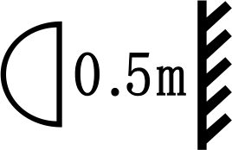
- Fixed installation, to prevent the strong vibration or impact of the device.
- The distance between the device and the projectile to keep at least 0.5 meter.

- Never look directly into the light source,as sensitive persons may suffer an epileptic shock(especially meant for epileptics)!
- When light output position of the device of dustproof glass breakage, cracks or other visible damage, user should replace the new glass to continue to use.

2. Installation
- When install this equipment please make sure there's no flammable surfaces (decorated things, etc) and minimum distance of 0.5M from the equipment to the flammable.

- The installation of the effect has to be built and constructed in a way that it can hold 10 times the weight and without any harming deformation.
- The installation must always be secured with a secondary safety attachment, e.g. an appropriate safety rope.Never stand directly below the device when mounting, removing or servicing the fixture.

- Product Specification
- Input voltage: AC100-240V
- Fuse: BGDP ￠5x20mm 250VAC T2A
- Power consumption: 24W
- LED: 5*3W (R1/G1/B1/W1/Y1), Strobe LED:5*1W (R1/G1/B1/W1/Y1)
- Laser: 100mw/650nm+30mw/532nm
- Control mode: sound/auto fast moving/auto slow moving/remote
- Max working Temp: 40℃
- Housing max ambient Temp：65℃
- Net weight：1.9Kg; Gross weight: 2.4Kg
- Inner packing size:28 X 18 X 21.5cm
- Outer packing size:58 X 38 X 46cm(8pcs)

4.Operation Menu

Operation Menu Map

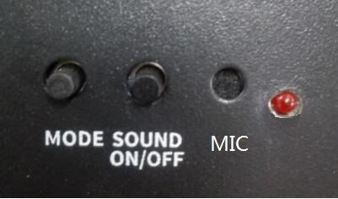

11
2
31

NO. | Silkscreen | Function
1 | MODE | MODE，Show 0-Show3 cycling show
1 | MODE | Show 0:Led + Laser + Strobe random show
1 | MODE | Show 1:Led show
1 | MODE | Show 2:Strobe show
1 | MODE | Show 3:Laser show
2 | SOUND ON/OFF | Sound switch，between Show Fast,Show Slow ,Show Sound
2 | SOUND ON/OFF | Show Fast：  Show 0-Show3 at fast speed LED indicator flickers fast
2 | SOUND ON/OFF | Show Slow：  Show 0-Show3 at low speed LED indicator flickers slow
2 | SOUND ON/OFF | Show Sound：  Show 0-Show3 controlled by sound，LED indicator flickers with sound beat
3 | MIC | Mic

5.Remote control map

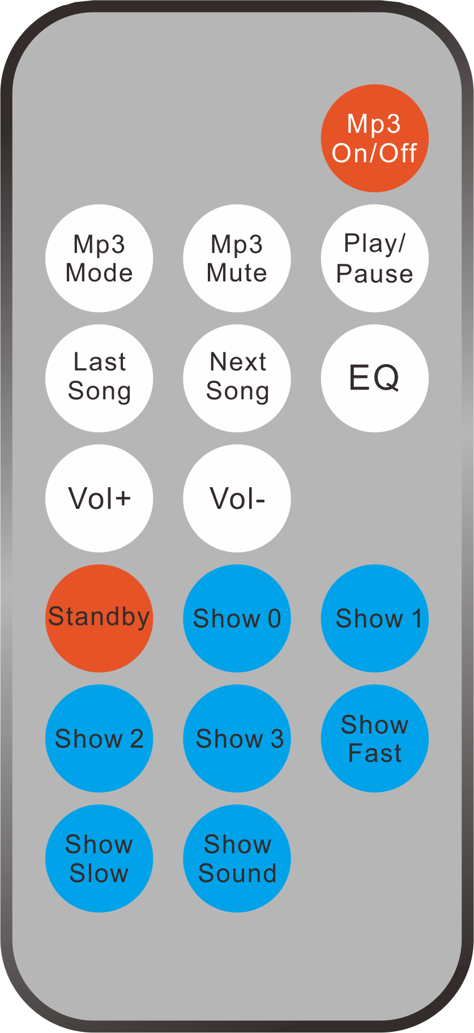
3

1

2
4

7
5
8
6
9
10
13
12
16
15

11
14
17

NO | Button | Function
1 | Mp3 On/Off | Hold on
2 | Mp3 Mode | Hold on
3 | Mp3 Mute | Hold on
4 | Play/Pause | Hold on
5 | Last Song | Hold on
6 | Next Song | Hold on
7 | EQ | Hold on
8 | Vol+ | Hold on
9 | Vol- | Hold on
10 | Standby | Light standby
11 | Show 0 | LED+Laser +Strobe, random show
12 | Show 1 | LED show
13 | Show 2 | Strobe show
14 | Show 3 | Laser show
15 | Show Fast | Show 0-Show3 fast show，LED indicator flickers fast
16 | Show Slow | Show 0-Show3 slow show，LED indicator flickers slow
17 | Show Sound | Show 0-Show3 controlled by sound，LED indicator flickers with sound beat


Ringing
1 Mounting bracket
2 Hanging bracket

- The applicable temperature for the lighting is between -25°C to 40°C. Do not use the lighting under or above the temperature.
- The installation of the effect has to be built and constructed in a way that it can hold 10 times the weight for 1 hour without any harming deformation.
- The installation must always be secured with a secondary safety attachment, e.g. an appropriate safety rope.Never stand directly below the device when mounting, removing or servicing the fixture.
- The operator has to make sure the safety relating and machine technical installations are approved
by an expert before taking the device into operation for the first time.
- These installations have to be approved by a skilled person once a year.
- M8 screws on the mounting bracket which for fixed between hanging bracket’s ￠12.5mm hole.

6. Product Size
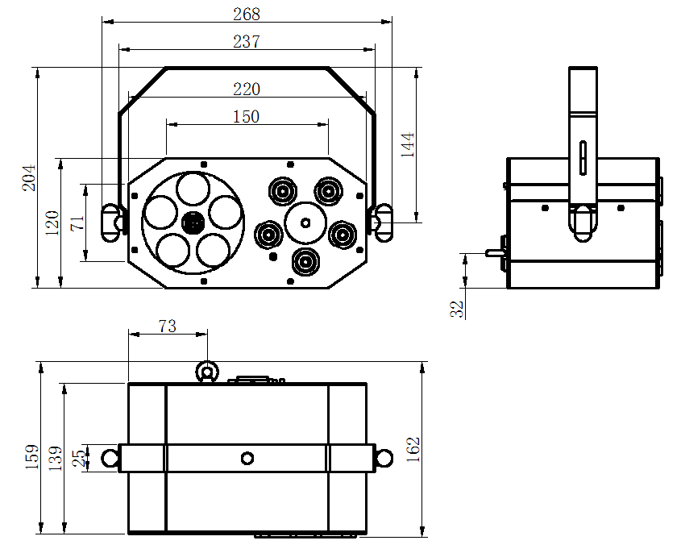
Cleaning and maintenance

Cleaning should be performed every 15-day period, by using a sponge which is dipped with alcohol, rather than wet cloth or other chemical liquid, to clean the mirror.

Cut off power before cleaning and maintenance!
CAUTION

Attention

Do not see directly light source when open the light, and make sure power off before do any installation or maintenance.

Wires connection must be professional person!
CAUTION

Warranty Card
This product is made of high-brightness transistor. We will provide 1 year warranty under the condition that user has operated the light normally and lifetime service. We won't provide warranty if the damage is caused by artificial or force majeure event. Cost of fittings should be charged by user if product need maintenance after 1 year .Please cut this warranty card and shipped it along with the product to our factory when applying for warranty.
Product： Purchasing date： Code of invoice：
Warranty date: From To
User’s name： Add：
Company： Tel：

